**Programming Bayes Rule**

**Complement**

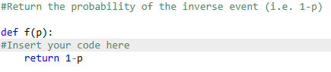

**Two Flips**

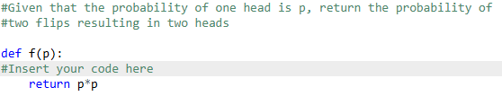

**Three Flips**

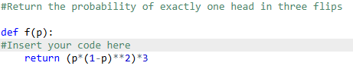

**Flip Two Coins**

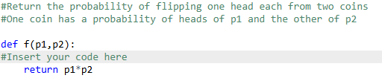

**Flip One Of Two**

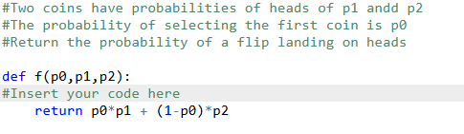

**Cancer Example Calculate Total**

